Functions

* Every function is stored in stack memory in the form of stack frame.
* All the variables that belong to a function are also stored in their respective stack frame.
* The top of the call stack contains the function which has the control (which is currently being executed).

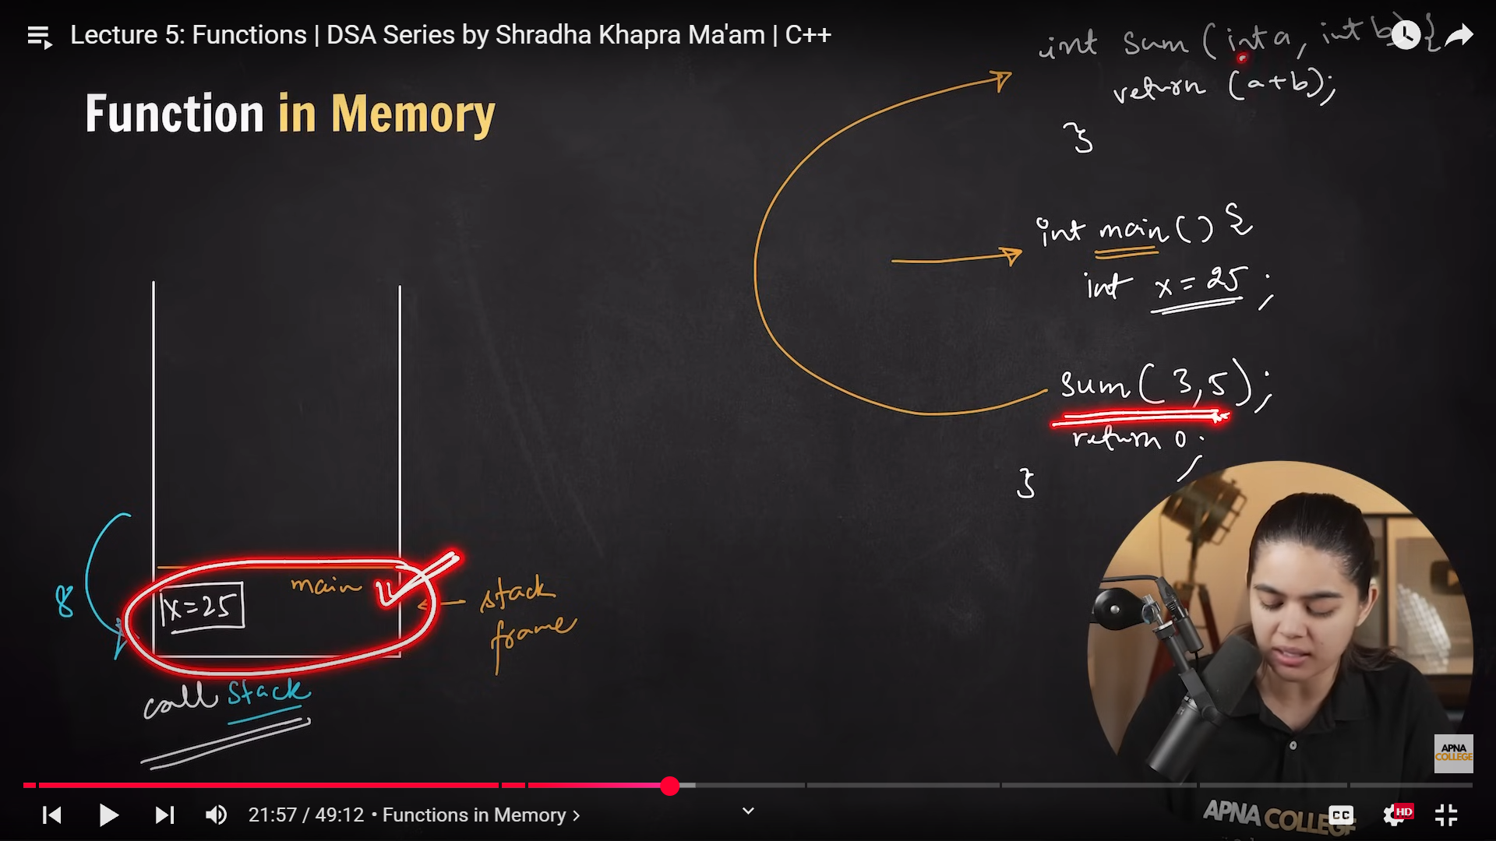

* Primitive Data Type variables are Passed by Value in a function.
* Data Structures like Vector, Array, Stack are always Passed by Reference.

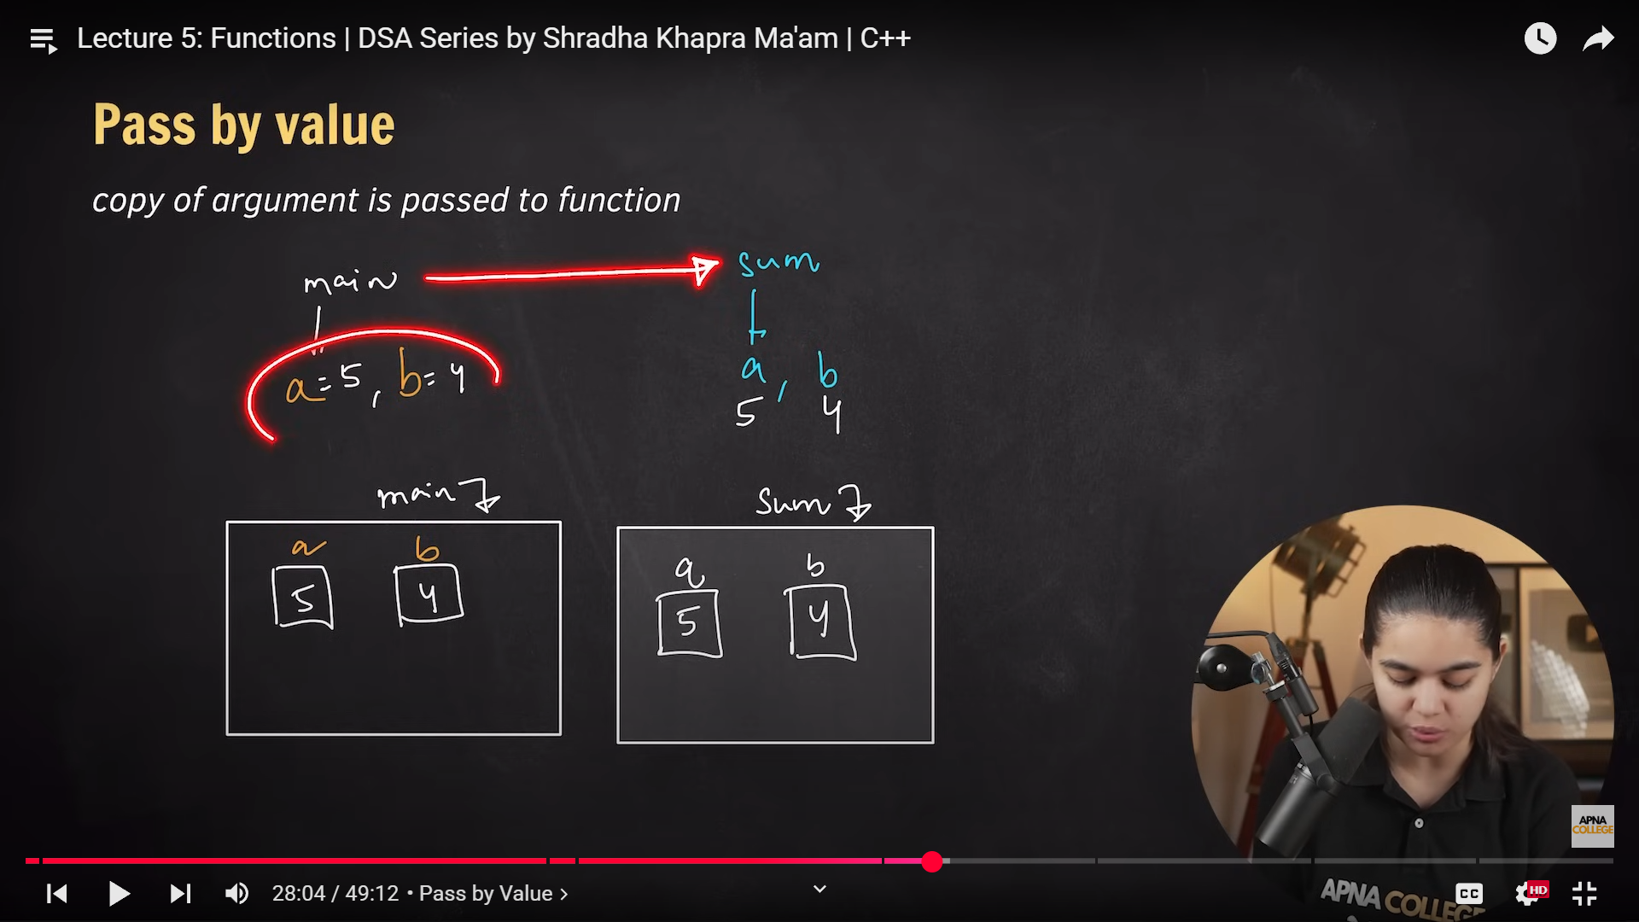

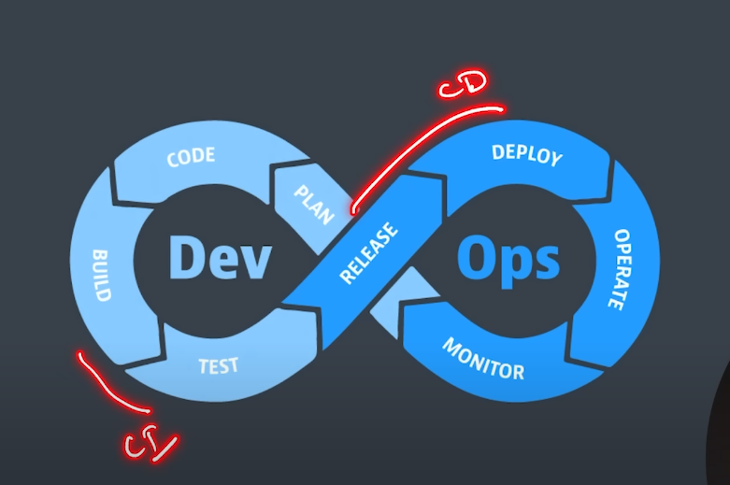

Decimal to Binary

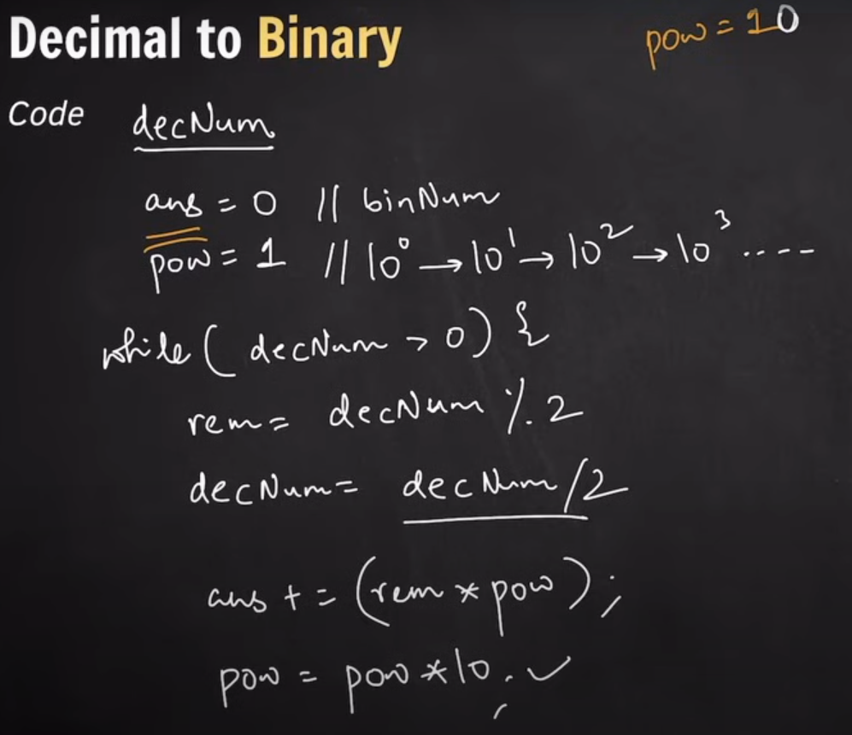

Binary to Decimal

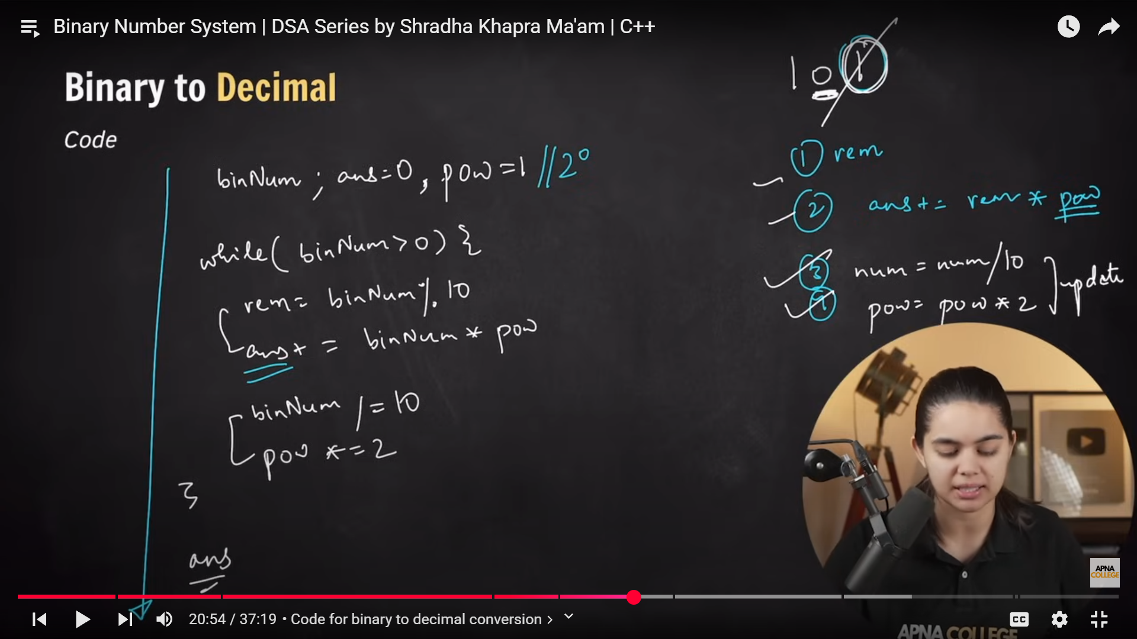

Two’s Complement

Decimal to Binary

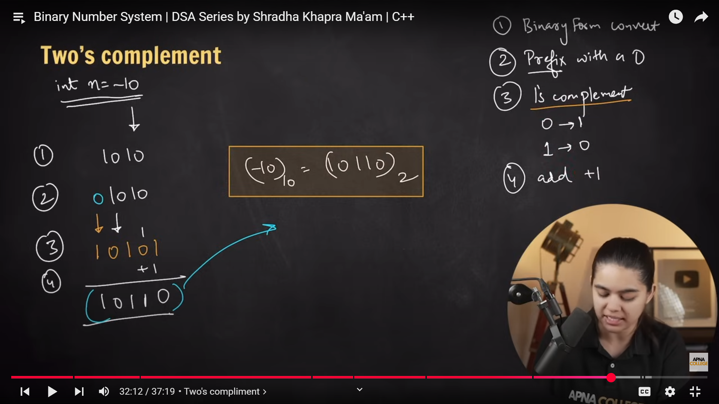

Binary to Decimal

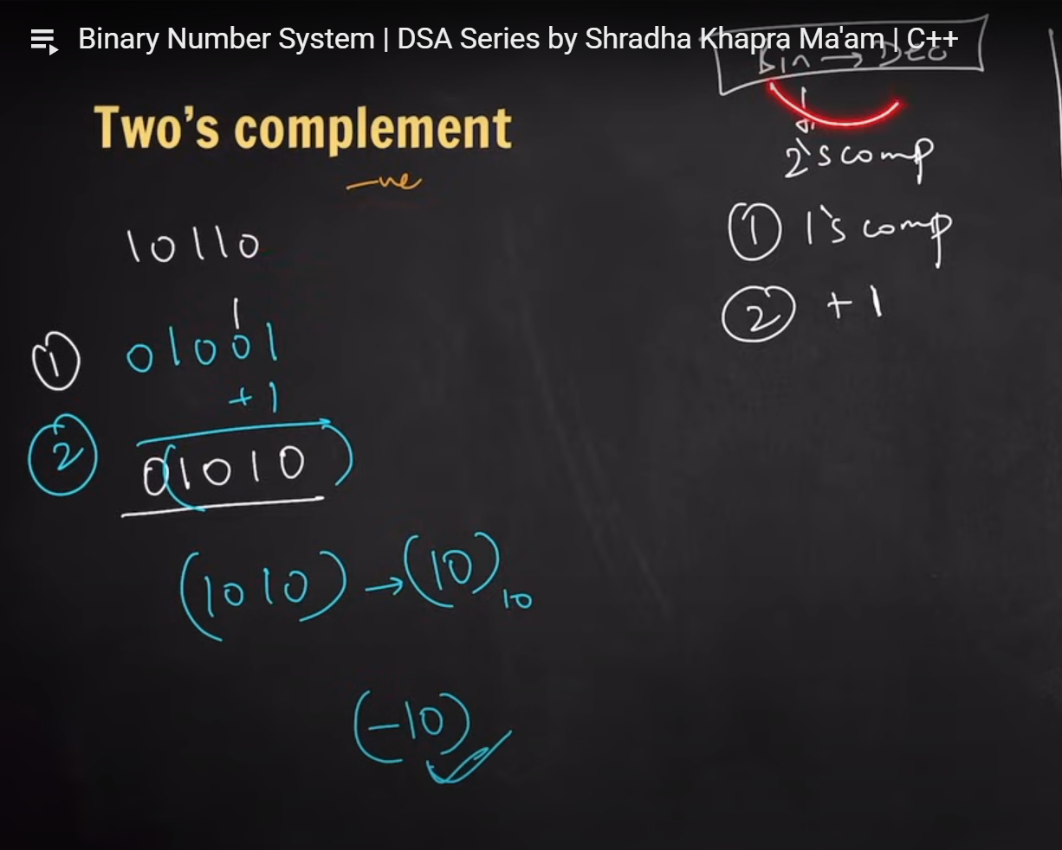

Bitwise Operator

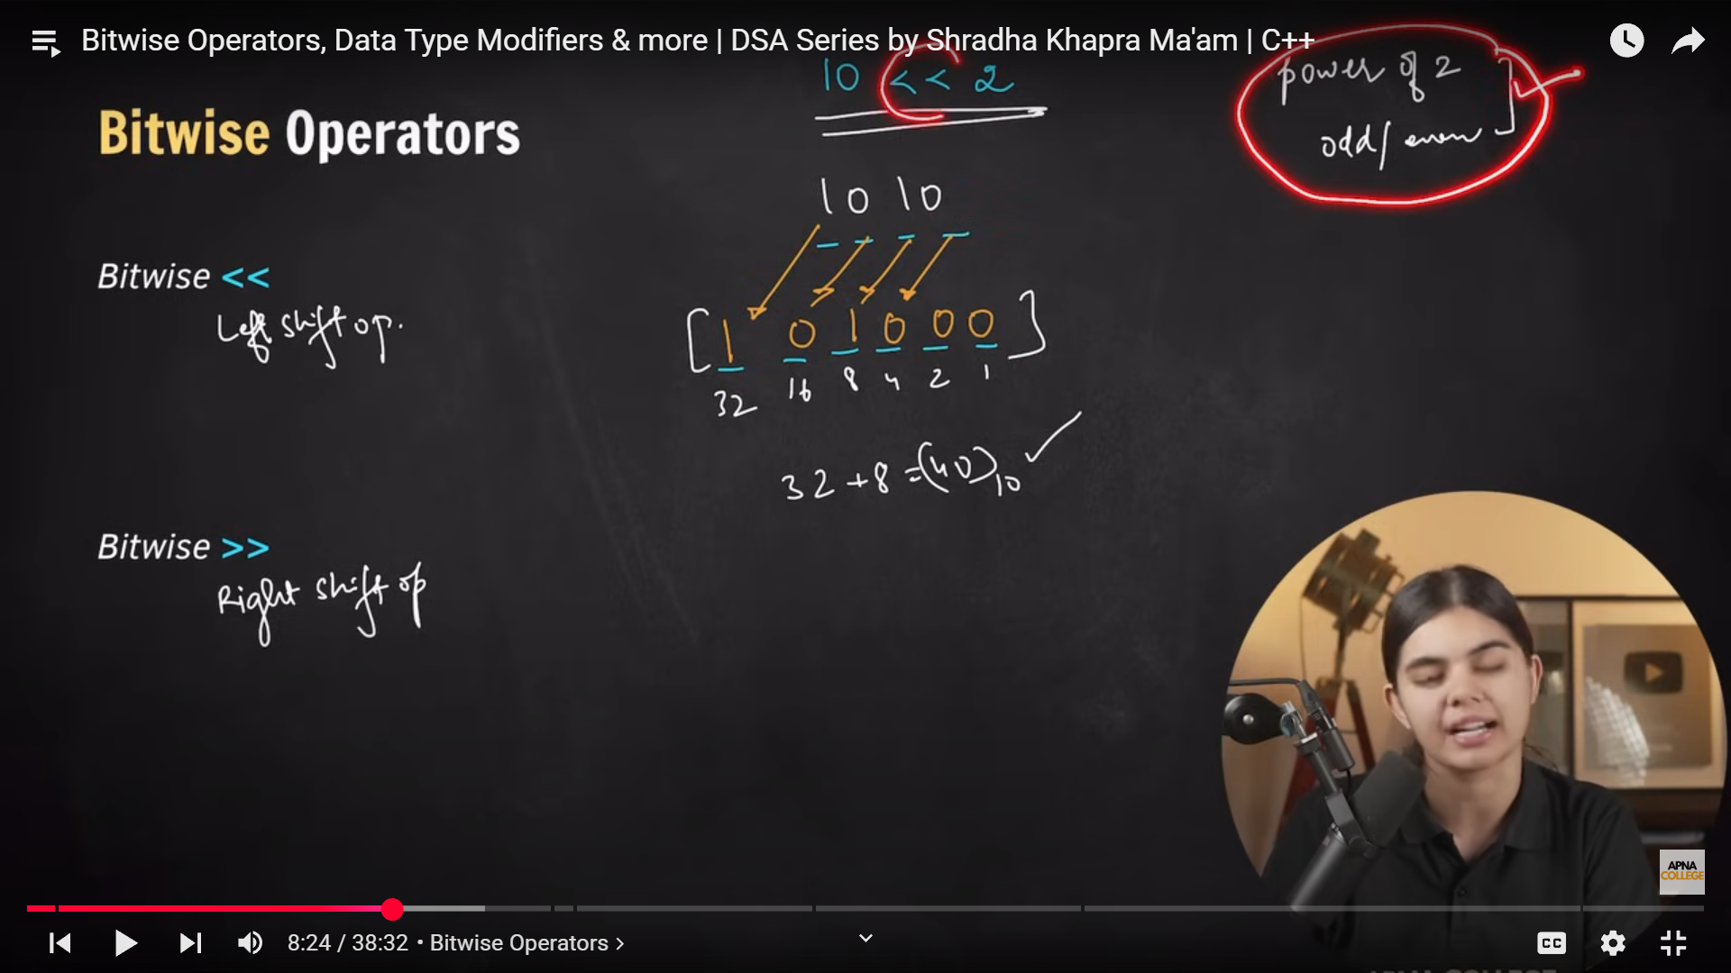

Each left shift multiplies the number by **2**.

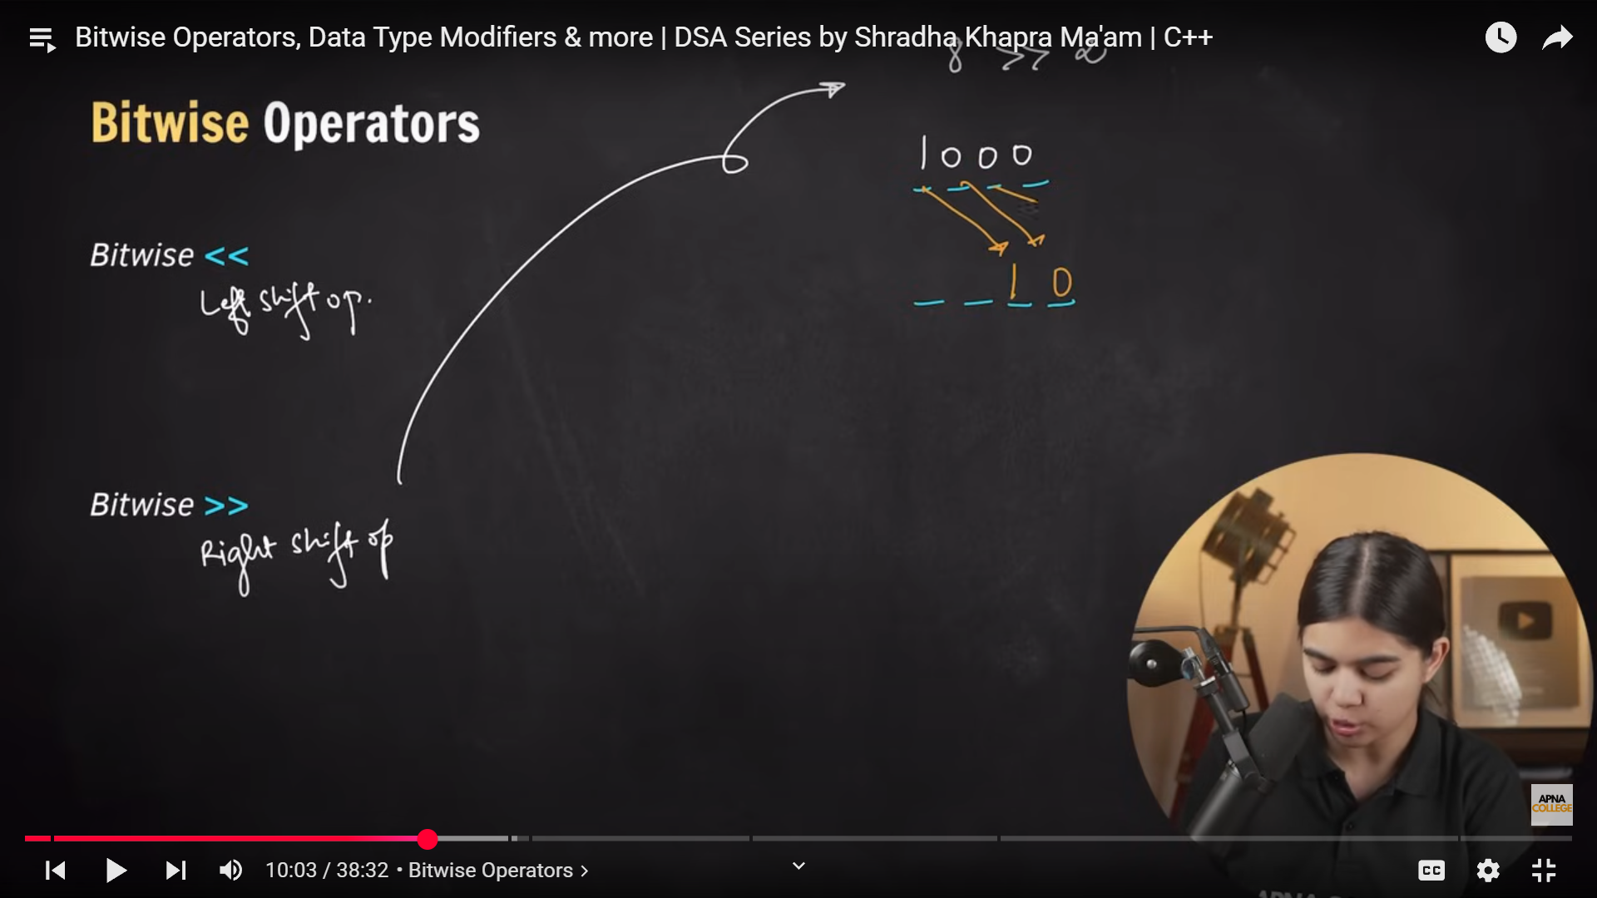

The **bitwise right shift (>>) operator** divides a number by powers of 2

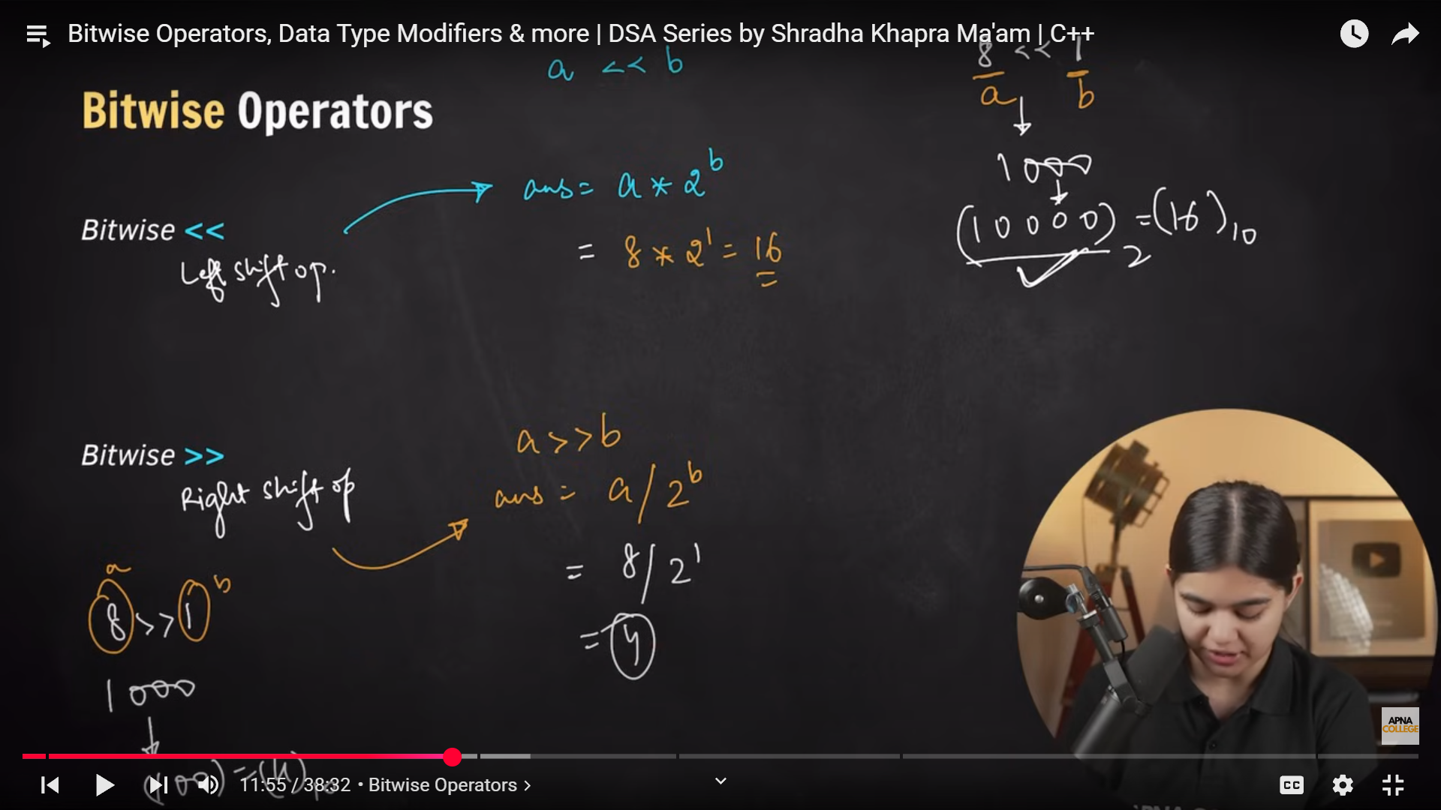

Operator Precedence

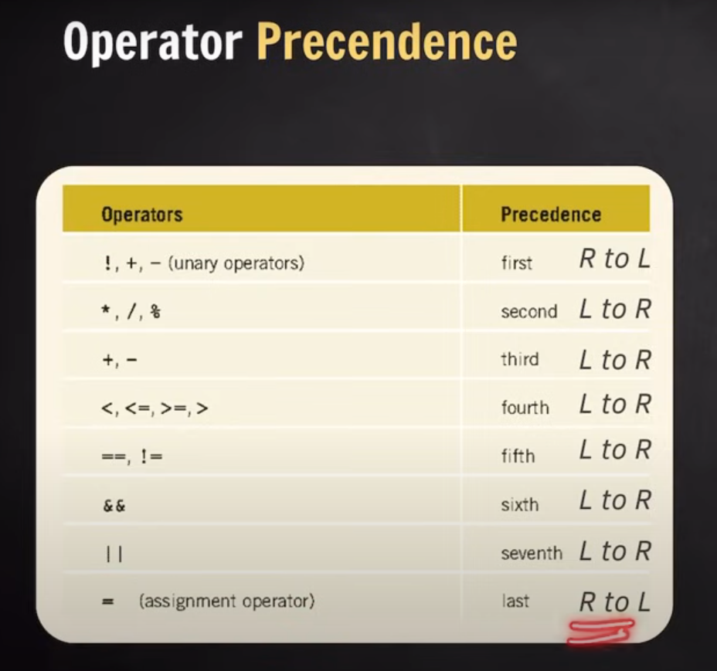

Data Type Modifiers

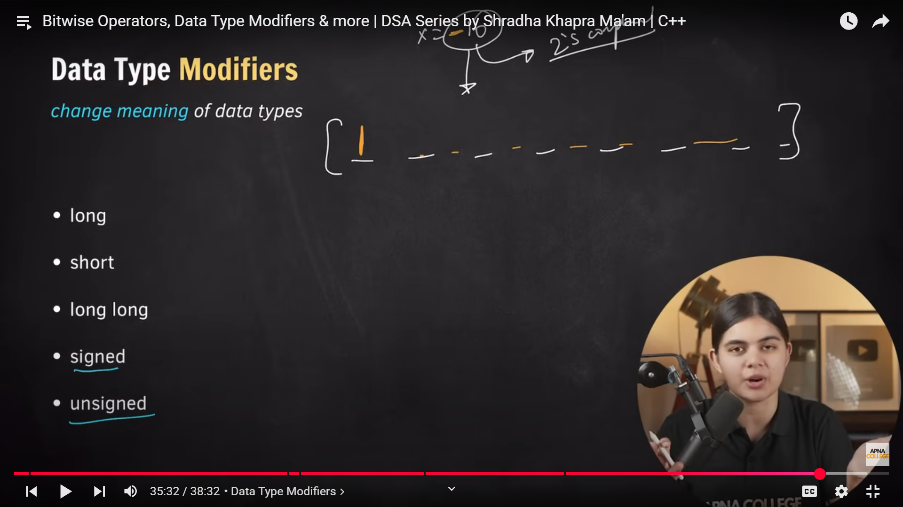

Reverse array using two pointer method

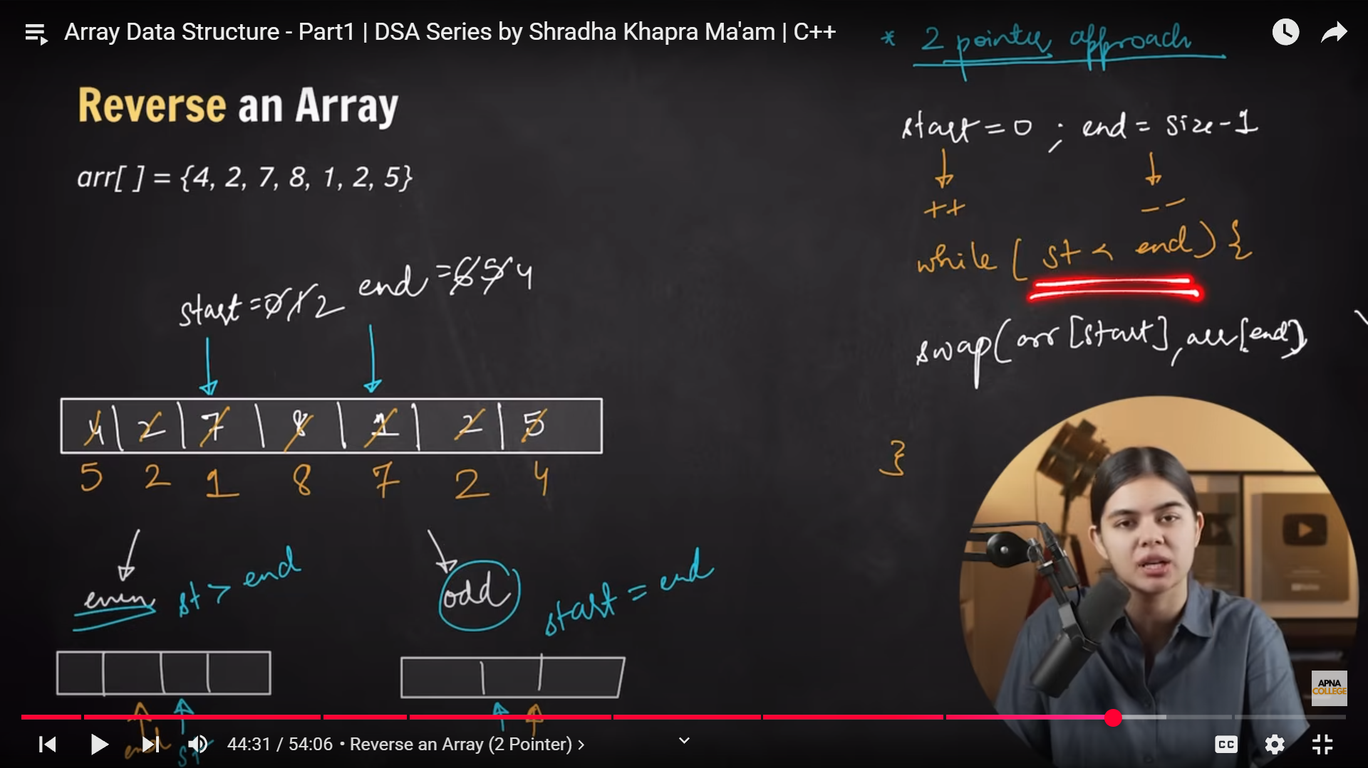

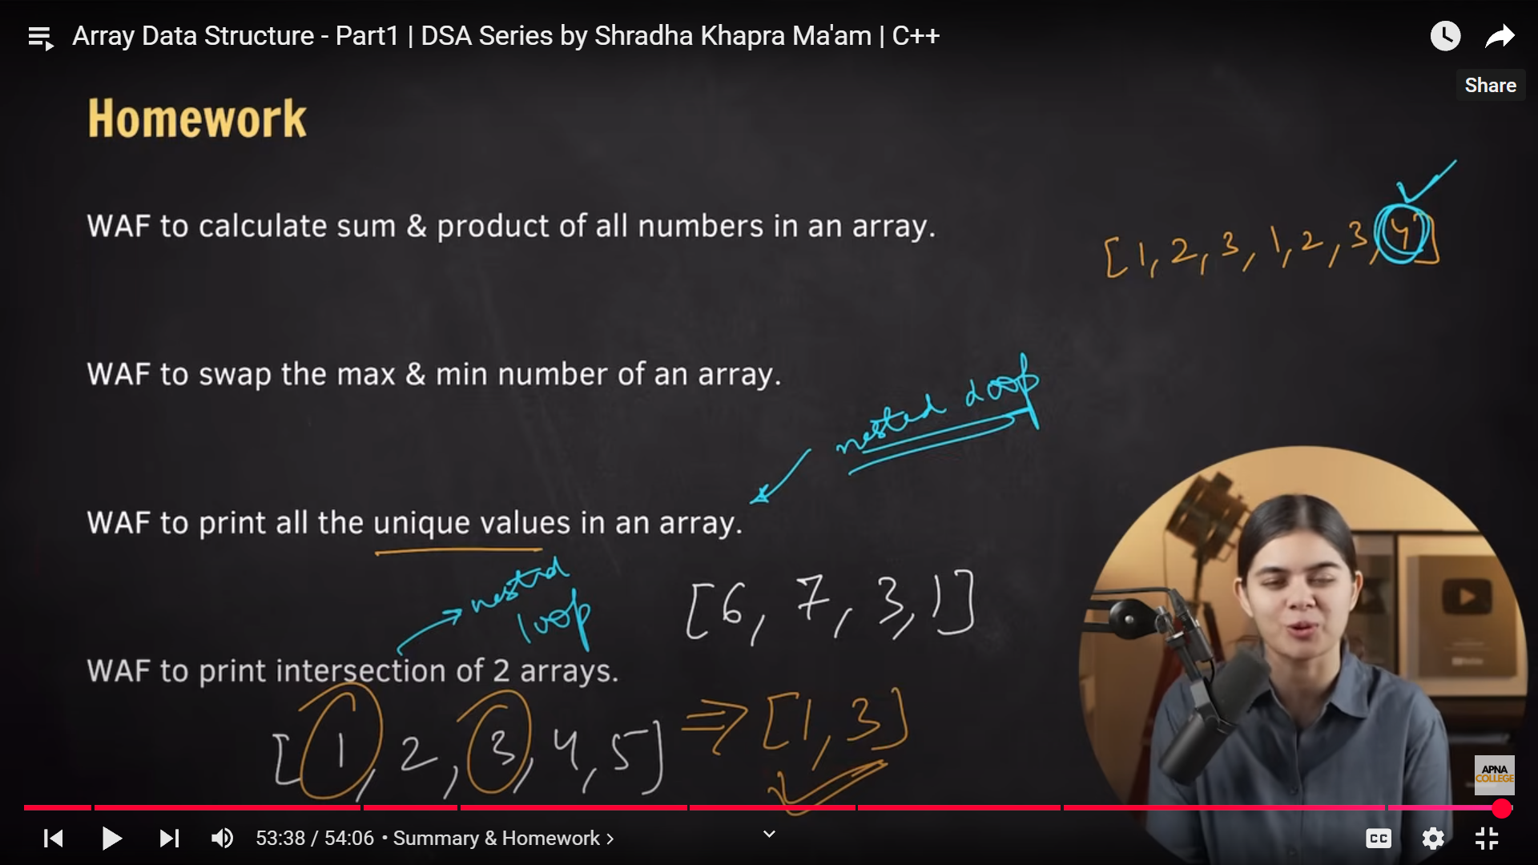

STL: Standard Template Library

Contains the implementation of data structures like vector, queue, stack, set etc. These data structures are also referred as STL containers.

Vectors: Similar to array but dynamic in nature i.e., size is not fixed.

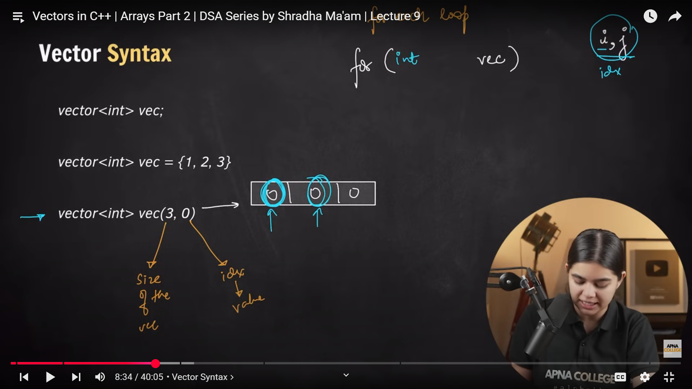

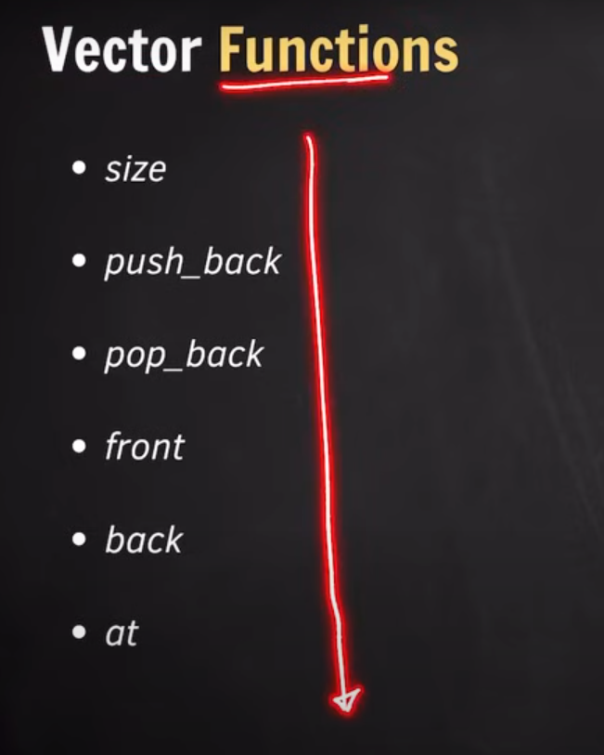

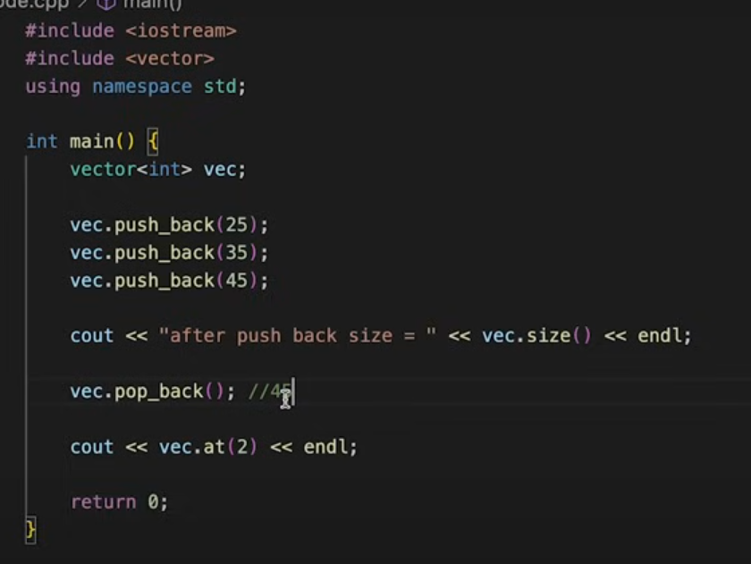

Dynamic Memory allocation is done in heap memory.

Vector size vs capacity

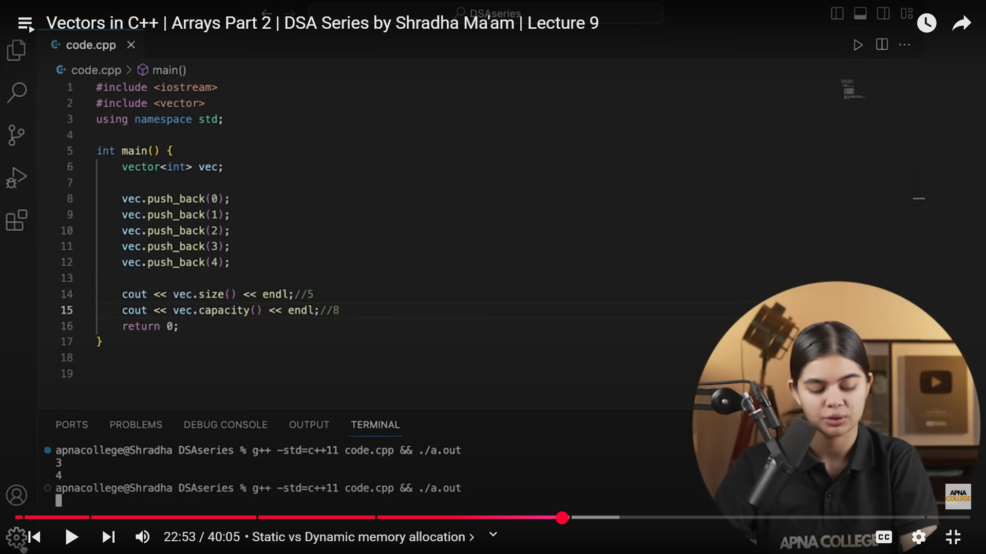

Non-primitive data structures like Array, Stack are by default passed by reference however, the STL containers like Vectors are passed by value, by default.